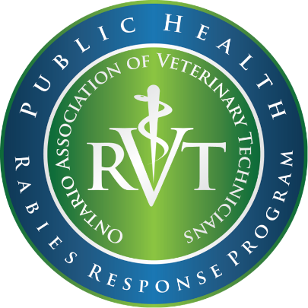

**Holiday/Weekend Testing**

**AN ANIMAL WILL ONLY BE CONSIDERED FOR RABIES TESTING ON A WEEKEND OR HOLIDAY IF THE FOLLOWING CRITERIA ARE SATISFIED:**

1. The animal is reasonably suspected of being rabid, based on a thorough investigation including consideration of the animal species involved, its behaviour at the time of the exposure, presentation of clinical signs consistent with rabies, geographical area, and for domestic animals, potential for previous contact with a rabid animal.

2. The person has suffered a WHO Category III exposure (i.e., single or multiple transdermal bites or scratches, licks on broken skin, contamination of mucous membrane with saliva).

3. There is a medical contraindication to receiving post-exposure prophylaxis.

4. The attending physician or Medical Officer of Health provides the laboratory with the name and telephone number of a contact who is readily available to receive and act upon the result on the day of testing. The laboratory must be able to speak with an individual, test results will not be left on an answering machine.

**How to request Holiday/Weekend testing:**

1) The PHU has ensured the case satisfies the four established criteria

2) If all of the criteria are satisfied the PHU will contact the ministry’s Public Health Veterinarian at:  [Heather.McClinchey@ontario.ca](mailto:Heather.McClinchey@ontario.ca)

3) After consultation with the PHU, Heather McClinchey will contact the OAVT Rabies Response Program to co-ordinate the collection and shipping of the sample.

4) The PHU will need to complete/submit the “OAVT Rabies Specimen Collection Request Form” which can be found [here](https://oavt.org/rabies-response-program/public-health-units/). The contact’s name and phone number provided for results, by the attending physician or Medical Officer of Health, must be included in the request.

5) Once received, the OAVT RRP will FAX or scan a completed page 4 from the CFIA’s guide to the CFIA laboratory. This must be completed and received by the CFIA 15 minutes before closing on the last working day prior to the weekend/holiday to inform the CFIA of sample submission. **Please note:** Testing can only occur if courier service can be arranged. Ottawa has Saturday courier service but no Sunday/Holiday service available. Lethbridge has no weekend or holiday courier service available. OAVT will complete the CFIA electronic submission form and shipping documentation and will arrange the RVT for collection and shipping.

7) The CFIA will report results to the contact provided by the attending physician or Medical Officer of Health, Heather McClinchey and the OAVT RRP.